The garden is a love song, a duet between a human being and Mother Nature  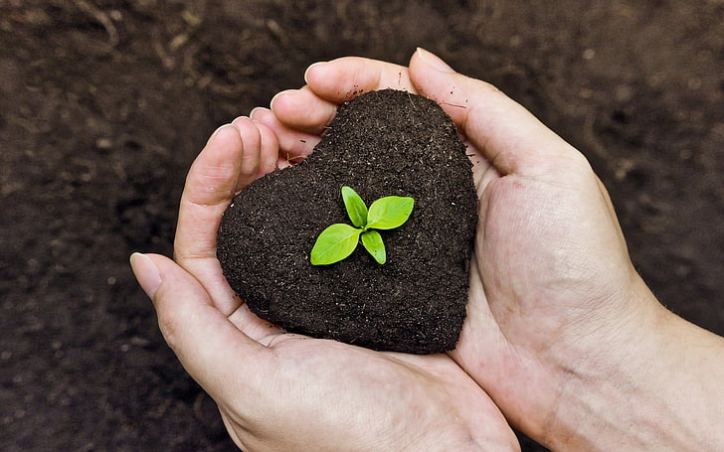 | Lakeside Garden Club  June 2024  Meetings are held the third Monday of each month at noon at the Olde Community Church, 9906 Maine Avenue, Lakeside CA 92040 unless otherwise noted from August-June.  Find us on Facebook
President  Jean Cabanilla*  Vice Presidents  Betty Corvey*  Patty Pepin*  Jenny Guilory*  Secretary  Patty Hemphill*  Carolyn Whitney*  Treasurer  Dennise Kane  Membership  Lisa Lang  Plant Sale Chair  Vacant  Propagation Workshops  Betty Corvey  Yard Art  Jennie Guillory  Bake Sale/Rummage Sale  Candy Cowell  Vicky Thompson  Webmaster  Mark Vettel  Hospitality  Clara Arvai  Historian  Esther Croteau  Newsletter/Parliamentarian  Cathie Robertson  Photographer  Nancy Pleasants-Vettel  Sunshine  Susie Robeson  Community Involvement &  School Gardens  Angi Mosier  Adrienne Lostaunau  Western Days  Vacant | Next Meeting  June 17, 2024  Tour of Betty Corvey’s Garden  11604 Jessica Lane  (Carpool if possible as parking is somewhat limited)  No July Meeting  ♣♣♣♣♣♣♣♣♣♣♣♣♣♣♣♣♣♣♣♣♣♣♣♣♣♣♣♣♣♣♣♣♣♣♣♣♣♣♣♣♣♣♣♣  What’s Happening in the Club?  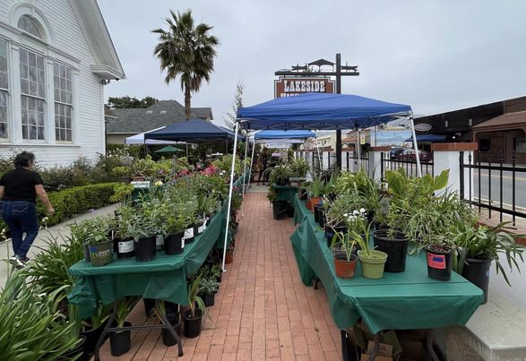  The calm before the wonderful “storm”- our Spring Plant Sale!  ♣♣♣♣♣♣♣♣♣♣♣♣♣♣♣♣♣♣♣♣♣♣♣♣♣♣♣♣♣♣♣♣♣♣♣♣♣♣♣♣♣♣♣♣  During our May meeting election of officers was held and everyone running was  Re-elected to a new term. Those elected have an asterisk* by their names (See left hand  side of this page.)

Page 2  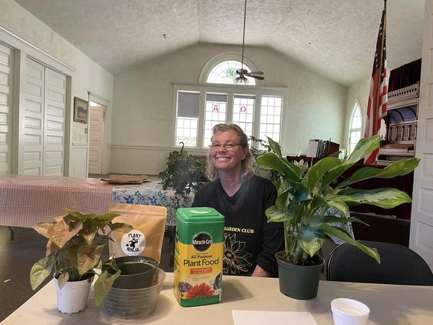  Our own Abby Moldenhauer talked to us about house plants.  ♣♣♣♣♣♣♣♣♣♣♣♣♣♣♣♣♣♣♣♣♣♣♣♣♣♣♣♣♣♣♣  Around Town  June 1st 9:00 a.m. Armstrong Garden Center, El Cajon. No class listed.  June 1st 9:00 a.m. Walter Andersen Nursery, San Diego. Mulching 101 with James.  June 1st 9:30 a.m. Walter Andersen Nursery, Poway. Staghorn Fern and Culture with Dave Ross.  June 3rd 7:00 p.m. San Diego Geranium Society. General Meeting. Casa del Prado Balboa Park, Room 101.  June 8th 9:00 a.m. Armstrong Garden Center, El Cajon. Hummingbird Happy Habitat. Register at https://www.eventbrite.com/e/a-hummingbird-happy-habitat-attracting-hummingbirds-and-more-tickets-911503510537  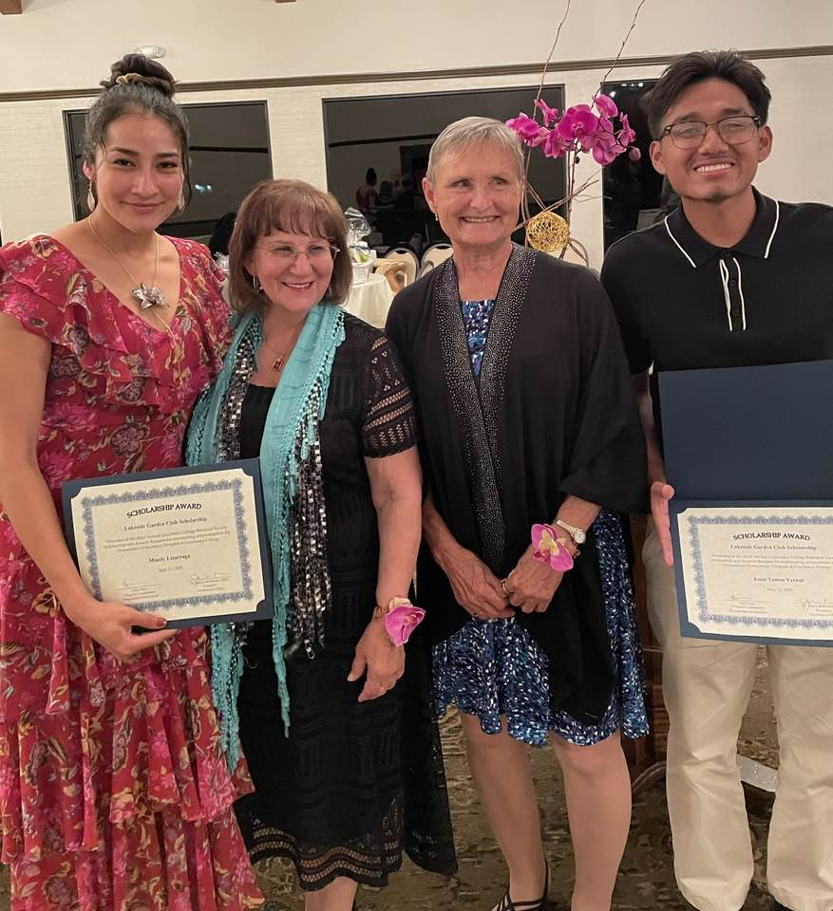  Betty Corvey and Jean Cabinalla with our two Cuyamaca  College scholarship recipiants.  Page 3 (Around Town continued)  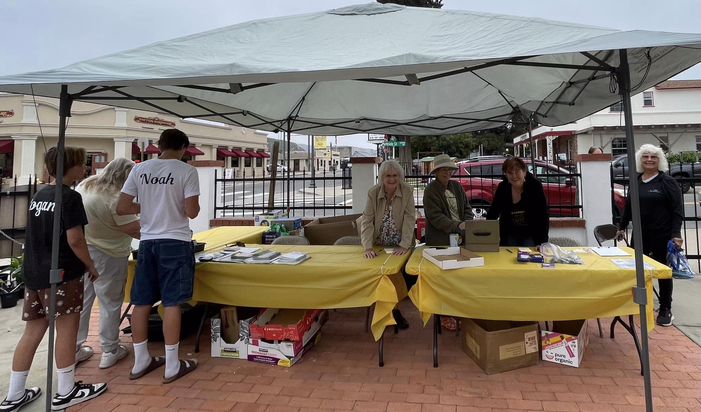  Our Check Out crew  June 8th 9:00 a.m. Walter Andersen Nursery, San Diego. Hummingbirds and Butterflies with Kathleen.  June 8th 9:30 a.m. Walter Andersen Nursery, Poway. Invasive pest for large trees with Pedro Berry.  June 8th 1:30 p.m. to 3:00 p.m. San Diego Horticulture Society. At Oasis in Rancho Bernardo, 17170 Bernardo Center Drive.  June 9th 9:00 a.m. to 12:30 p.m. San Diego Bonsai Club. Repotting Workshop Casa Del Prado, Balboa Park, Room 101.  June 15th 9:00 a.m. Armstong Garden Centers. No class listed for this week.  June 15th 9:00 a.m. Walter Andersen Nursery, San Diego. Bonsai basics with Richard.  June 15th 9:30 a.m. Walter Andersen Nursery, Poway.  Vermicomposting the easy way with Dean..  June 22nd 9:00 a.m. Armstrong Garden Centers. No class listed for this week.  June 22nd 9:00 a.m. Walter Andersen Nursery, San Diego. Container gardening with Constanze.  June 22nd 9:30 a.m. Walter Andersen Nursery, Poway. Tropical fruit care with Mike.  Page 4 (Around Town continued)  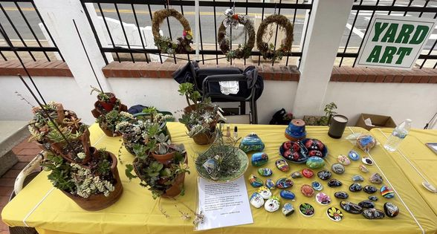  Our Art table at the sale  New Feature: Gardening Tips  (If you have a gardening tip or find one you would like  to share, please bring them to the garden club meetings  and give them to Cathie Robertson. She will share  in the newsletter and some will be included in our cookbook)  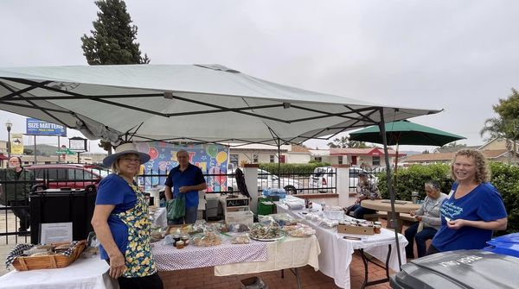  Our bake sale wonderful bakers and helpers! It was a huge  Success!  Garden Club Cookbook Project  In progress.   |   To our June Birthdays, Happy  Birthday to: Ruth Casady, Jennifer Luke,  Welcome New Members:  No new members in May  Veggies to plant in June  beans, beets, cantaloupe, carrots, corn,  cucumbers, eggplant, jicama, kale, lettuce,  lima beans, spinach, okra, parsley, peas,  peppers, pumpkin, radish, squash,  strawberries, sunflower, Swiss chard,  tomatoes, watermelon  Things to do in the garden in June  Plant irises, caned roses, tropicals,  tuberoses, zinnias and other heat loving  flowers, morning glories, warm season  grasses, melons, pumpkin, perennials,  clematis.  -Transplant potted bulbs into the ground  -Replace cool season bedding flowers  with  heat loving bedding plants  -Continue planting summer veggies  -Purchase plant and transplant succulents,  cacti and euphorbia.  -Aerate and mow all lawns.  -Thin out fruit on deciduous fruit trees.  -Pinch dahlias back  -Deadhead and disbud roses.  -Prune camellias  -Clean and prune azaleas.  -Prune winter and spring blooming vines,  trees  and ground cover after blooming.  -Continue  tying up tomatoes.  -Propagate daylilies.  -Deadhead and cut back perennials.  -Fertilize citrus, avocados, begonias, corn,  camellias, azaleas, roses, ferns,  flowerbeds,  flowering shrubs and lawns.  -Water all garden plants, especially roses  and veggies as needed.  -Control pests on roses and veggies.  -Control weeds  -Control gophers (Black Hole traps work  well)  -Mulch to retain moisture and control weeds  -Harvest veggies and citrus  Most Info from ‘Pat Welsh, Pat Welsh's Southern  California Gardening: A Month-By-Month Guide’.  Her book, “Pat Welsh’s Southern California Organic  Gardening, Month-by-Month”, Chronicle Books is  also now available and provides more detailed info.  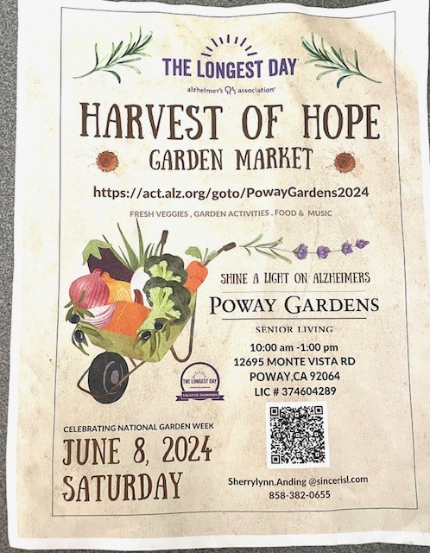  A Farmer Roy suggestion  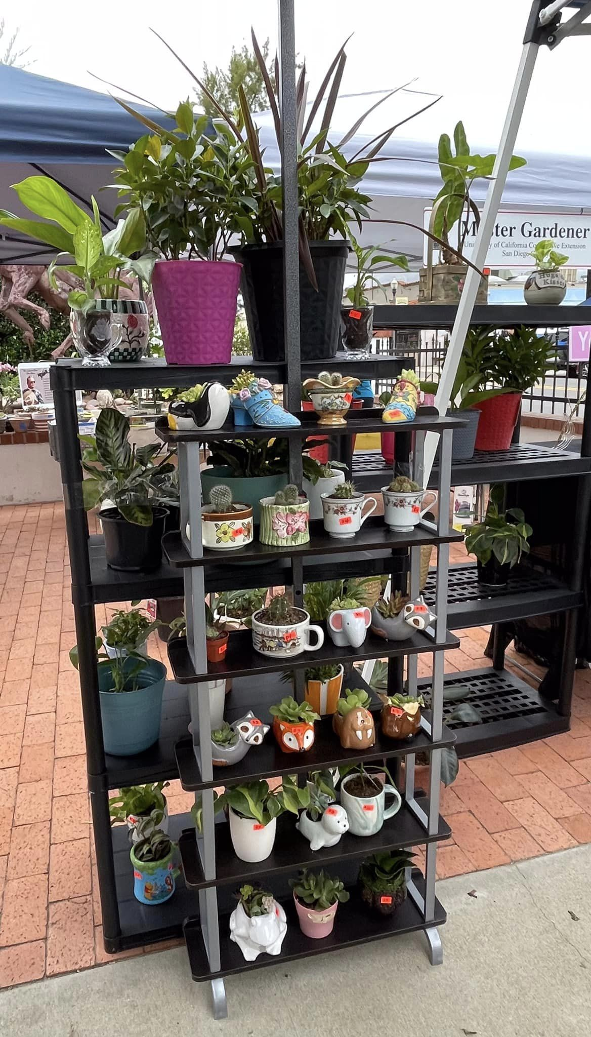  Sherry’s fabulous potted plant booth  JUNE RECIPE CORNER  This was requested at our May potluck.  Ree Drummonds Super Chocolate Cake  1 box of chocolate cake mix  1 cube butter melted  1 cup milk  3 eggs  2 tsp. vanilla  - ½ cups chocolate chips  Mix the cake mix with the eggs, milk, butter and  Vanilla. Add the chips. Pour into a bundt pan.  Bake at 350 Degrees F for 40-45 minutes or  until cake bounces back and is done. Cool  30 minutes before removing from pan.  Ganache  1 cup chocolate chips and ½ cup cream  Cook together in the microwave about 1 and ½ to 2  minutes. Stir frequently. When thickened, pour  over cooled bundt cake. Sprinkle with Heath  Bar crumbles.

